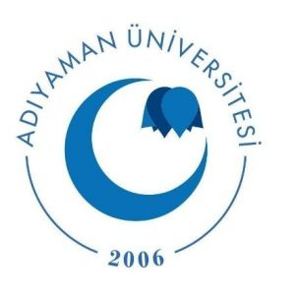
REPUBLIC OF TURKEY ADIYAMAN UNIVERSITY  International Relations Office |  | 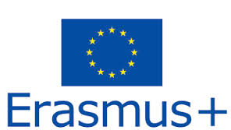

TO WHOM IT MAY CONCERN

Öğrenci Adı soyadı is a student at the Adiyaman University; Faculty of Dentistry student number öğrenci numarası. She/He has been selected within the framework of the Erasmus+ Student Mobility Program and will be visiting the öğrencinin gideceği kurumun adı within the framework of Erasmus+ Traineeship Programme from 15 Octaber 2024 to 15 December 2024 (Gideceği tarih aralığı). The student will be granted 600/750 Euros per month and 1500 Euros in total by the European Commission for the Mobility Program.

l would be very glad if you provide a related visa for our student.
Yours Sincerely.

07 May 2024

Prof. Dr. Selcen YÜKSEL PERKTAŞ
Head of International Relations

